## GUI window after successful serial connection with the Hardware

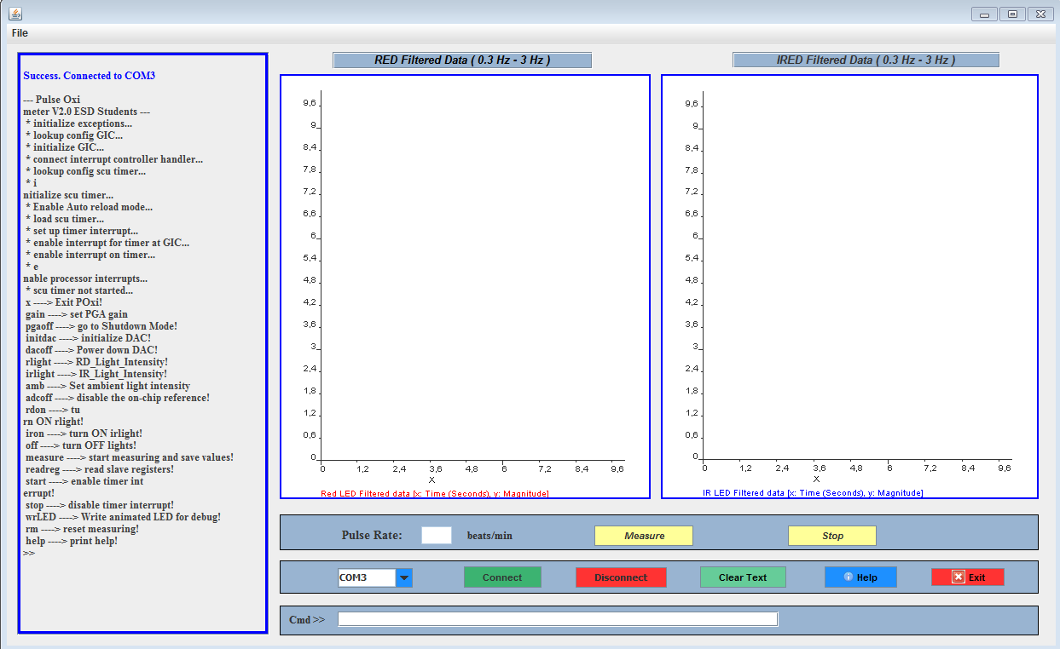

Figure 9.1: GUI window after successful serial connection with the Hardware

## GUI Window Captures with Different Red and IR LED intensities

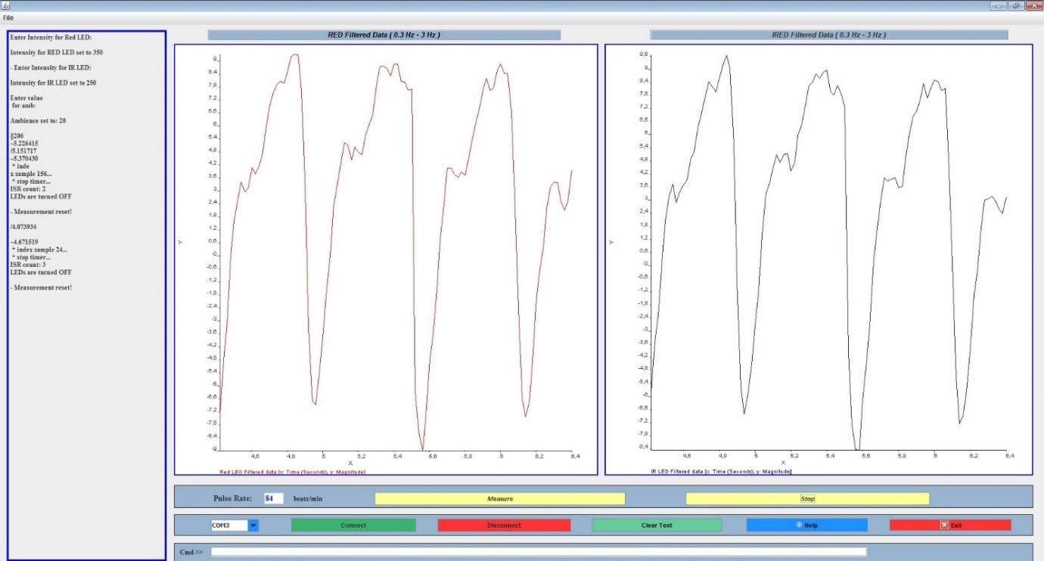

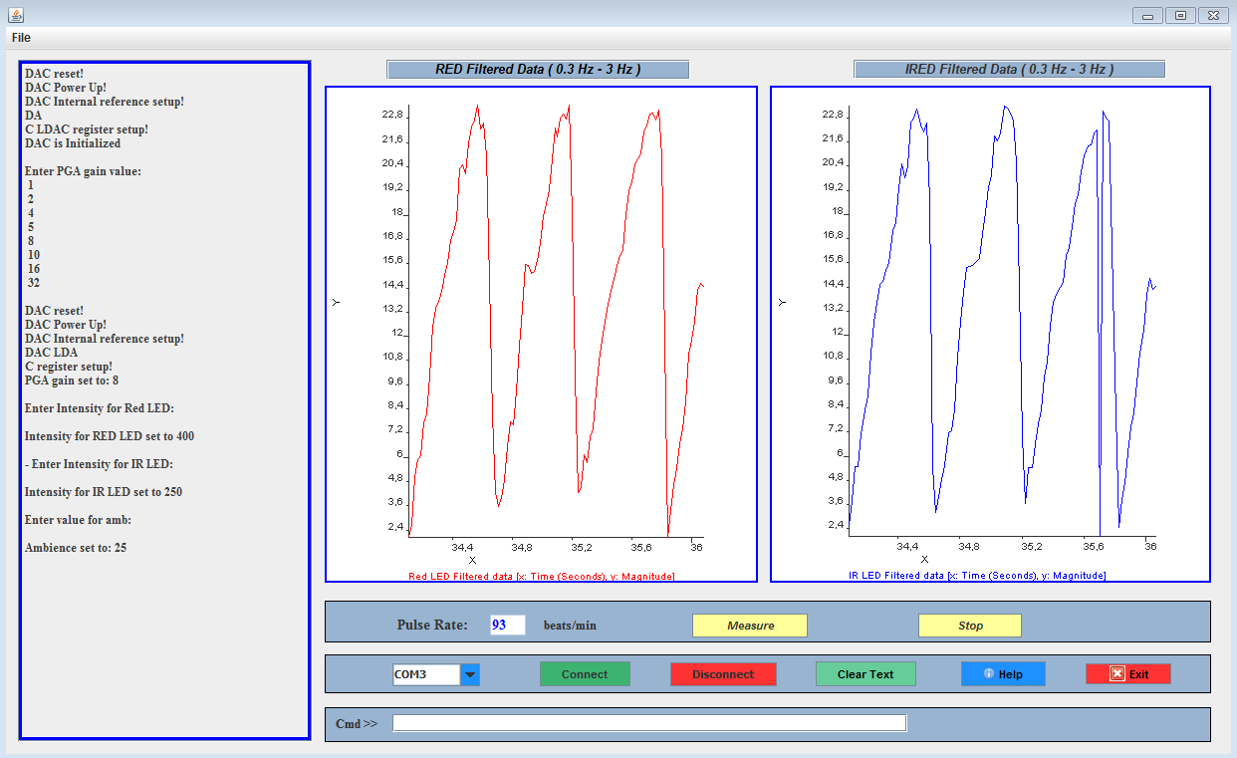

## Live Running Output of the Pulse Oximeter



Figure 9.2: Live Running Output of GUI Window